Greedy Algorithm --- Fractional Knapsack

**Fractional Knapsack**

Task Schedule

# Explain the problem

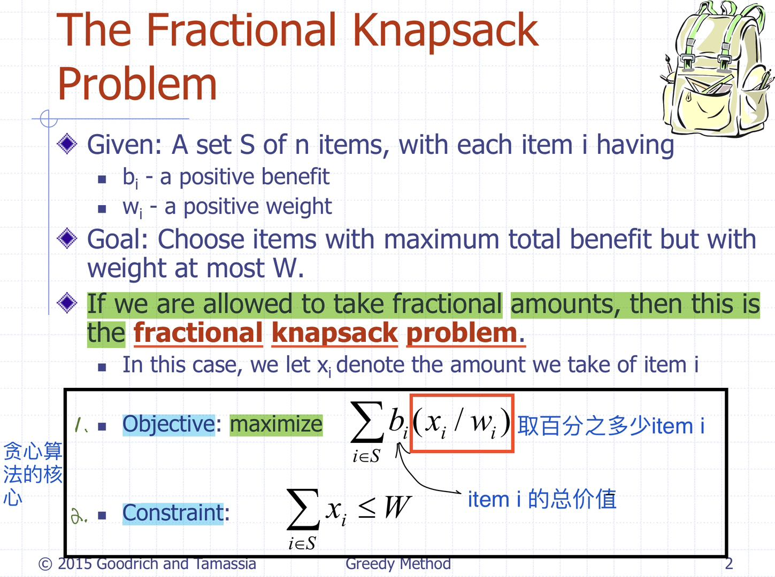

**注意绿色部分和贪心算法的核心**

# Give an example or given an instance of the problem, solve it

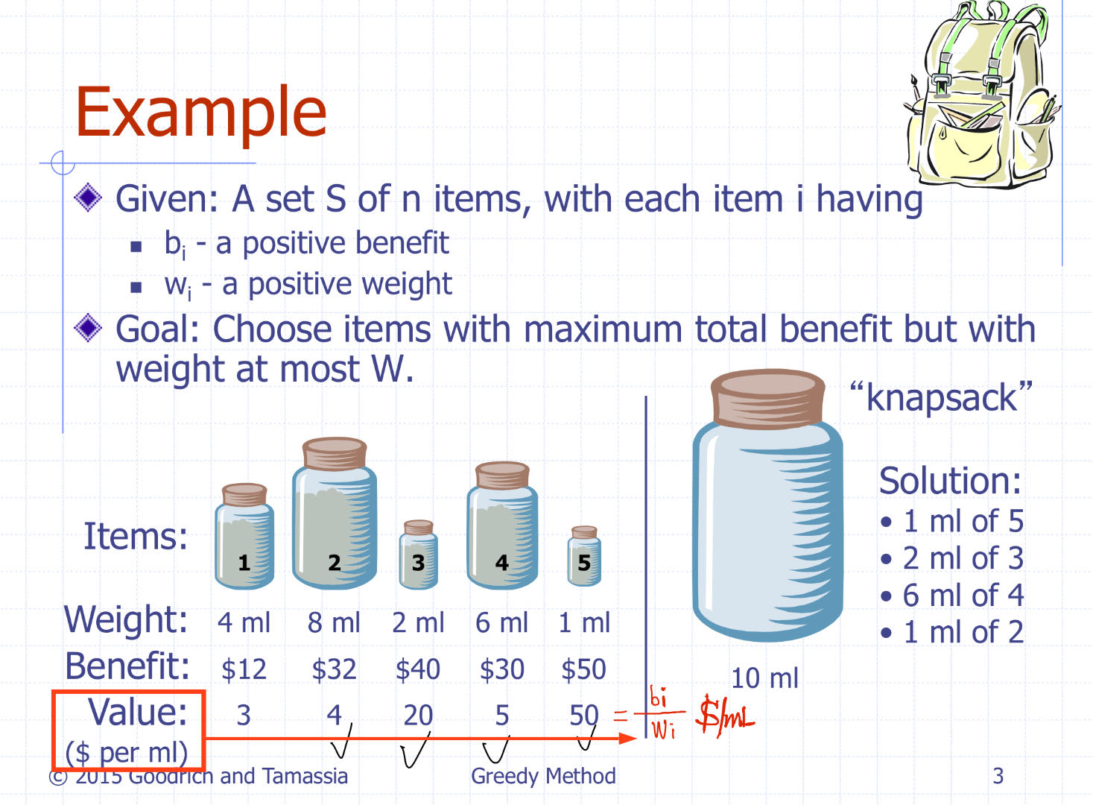

# Explain the algorithm and how are choices made and why, any important properties involved in making such a choice

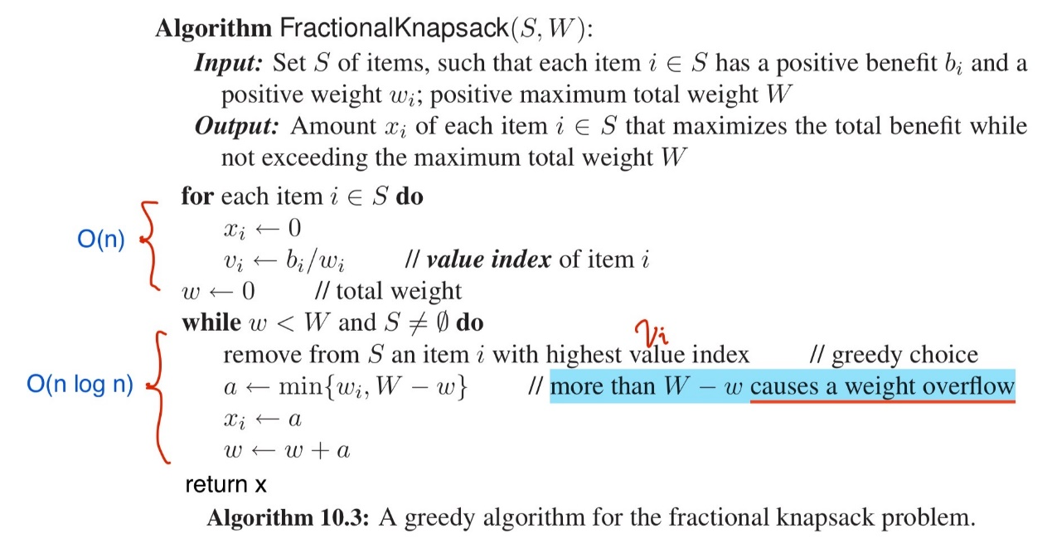

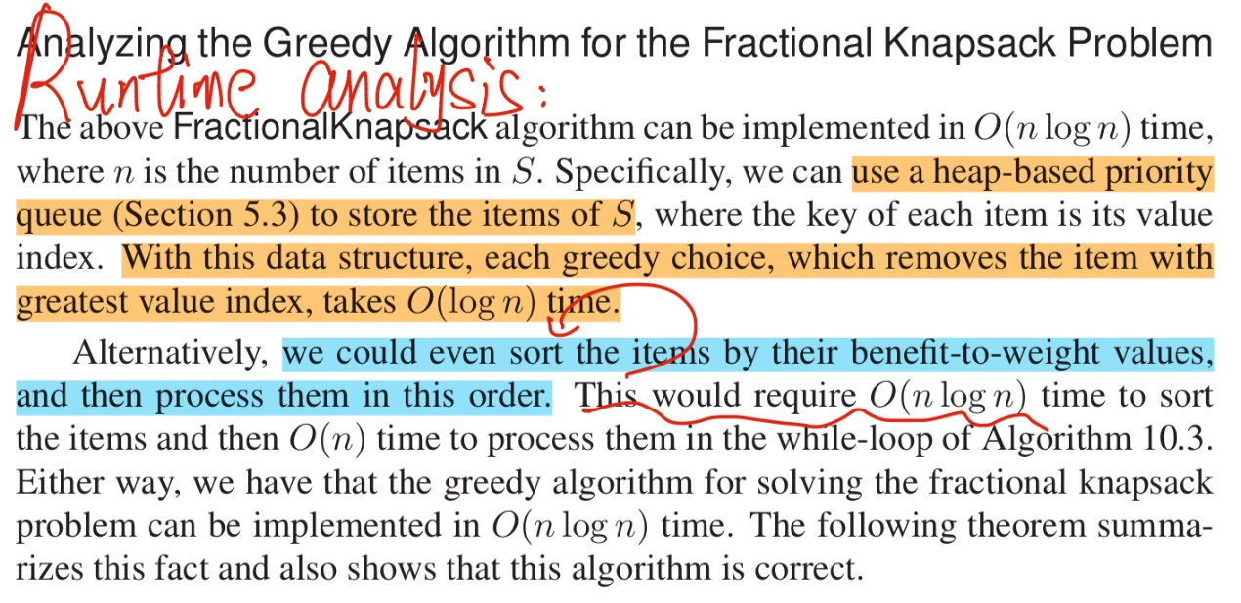

# Is it greedy or dynamic or some other type of algorithm, explain why?

For fractional Knapsack problem, we do not think about the subproblem overlap. And Sum(local optimal) is the global optimal. And Greedy algorithm is faster than Dynamic programming for this question.

# Compare/contrast the problems and algorithms



# Given a scenario would you use 0-1 Knapsack or Fractional Knapsack, or

# You give a scenario of when using 0-1 knapsack is appropriate and when Fractional is appropriate

# Given Fractional Knapsack algorithm prove it is correct, that it returns an optimal choice of weights of item to be included in the knapsack

